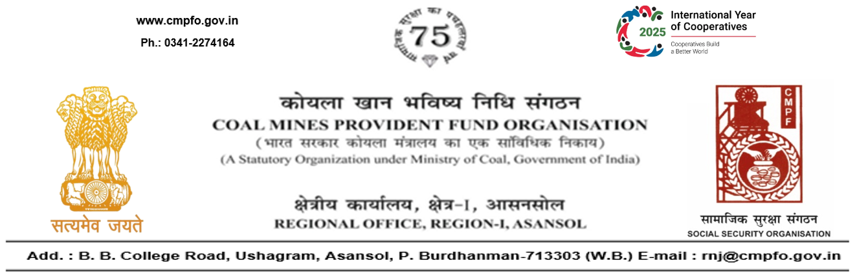
CPF/118/Misc/L.C.Out./RNJ-38/R-I/ASN/ Date: 01/01/2026

To
The Regional Commissioner
C.M.P.F, Singrauli
PO-Jayant Dist-Singrauli-486890
Madhya Pradesh

Sub:- Inter Regional Transfer of Ledger Card, DA, PS -3 & 4.

Ref:-CPF/118/ L.C. Req./SING/2321 dated 11/12/2025
Sir,
In view of the revised Procedures prescribed in Procedure Office Order No-35 Dated-12.02.1975 of CMPF Commissioner,Dhanbad, I am to state that the Ledger Cards of the following members is hereby forwarded to your Regional Office. Further, it is informed that the Form A & P.S.-3 & P.S.-4 forms are not available in this region.
It has been ensured that the posting in the Ledger Cards have been made/updated for the periods the member was working in this Region.

SL. No | Name of the Member | CMPF A/C No | Name of the colliery where the member had earlier worked in | Name of the colliery where the member is currently working in
1 | Shri Paras Nath Singh | JBP/63/3288 | Mic Jhanjra Colliery (RNJ/38) | NCL HQ. (SING/6)

Please acknowledge the receipt of the above at the earliest.

Yours faithfully,

(Ajay Kumar Singh)
Encl- Original L.C. (TwoNos) Regional Commissioner - I

